Date: October 27th, 2014

Subject: DFARS Specialty Metals Fastener Self Certification

To Whom It May Concern:

Jergens Inc. certifies that it will purchase, during the relevant calendar year 2014, an amount of domestically melted or produced specialty metal, in the required form, for the use in the production of fasteners for sale to Department of Defense and other customers, that is not less than 50 percent of the total amount of the specialty metal that Jergens Inc. will purchase to carry out production of such fasteners for all customers. Therefore, we consider the commercial fasteners produced by Jergens Inc. to comply with DFARS 252.225-7009.

Applicable supporting documentation will be made available to appropriate parties upon request with 30 days notice.

Please feel free to contact us regarding any questions you may have.

Respectfully,

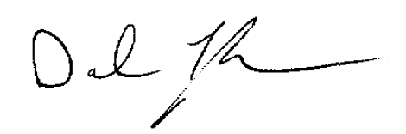
Darel Taylor
Engineering Manager
Jergens Inc.

